**SEQUENTIAL DIAGRAM**

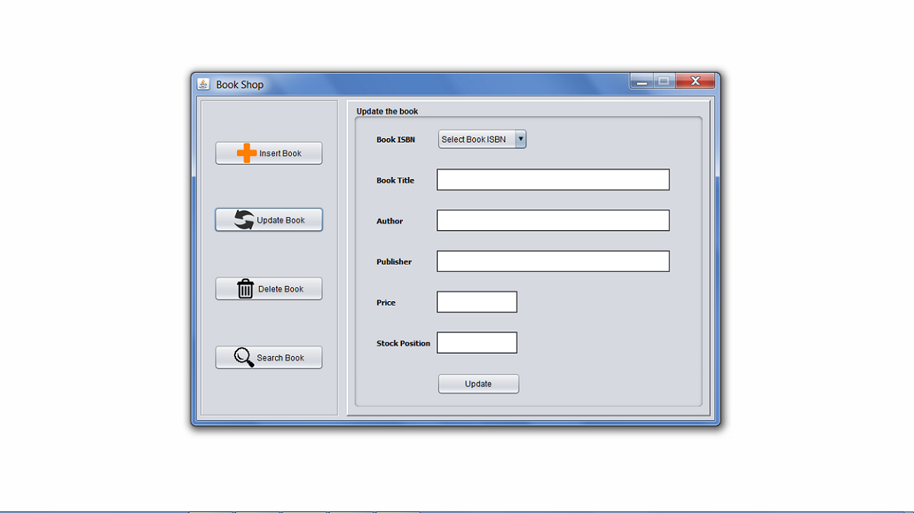

Update Book Interface

In above Interface, the user will select the book isbn from combo box and selective details of book will be displayed in their corresponding fields and after updating the wanted details and pressing the **UPDATE** button, validation of fields will be checked. If validated successfully, book details will be updated:

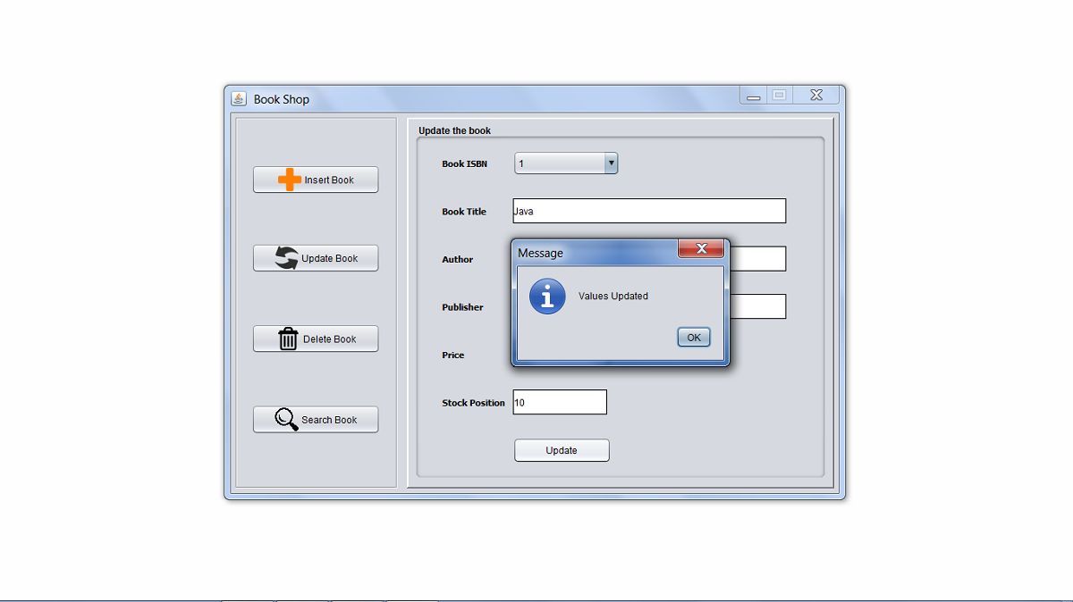

If any field updated contains error then error will be displayed: